**Weather report**

I noticed it is very cold every day in my favourite Northerly venue – take a look at the 5 day forecast:

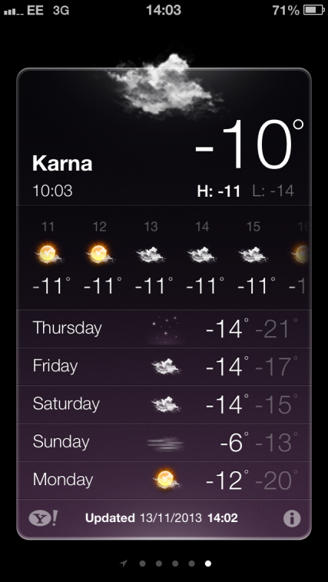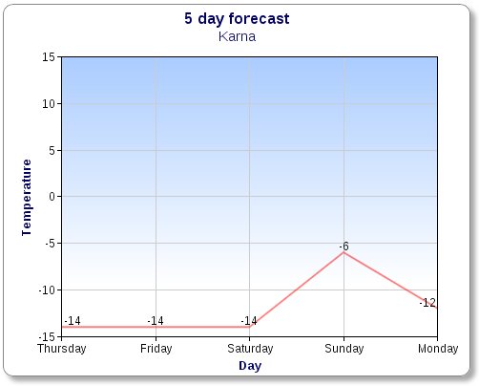

What do you think the temperature will be next Tuesday daytime?

By how much did the temperature change each day?

Graph the night time temperatures and answer the same questions.